BIRDCLEF+ 2026
Acoustic Species Identification in the Pantanal
Kaggle-Based Machine Learning Laboratory Report

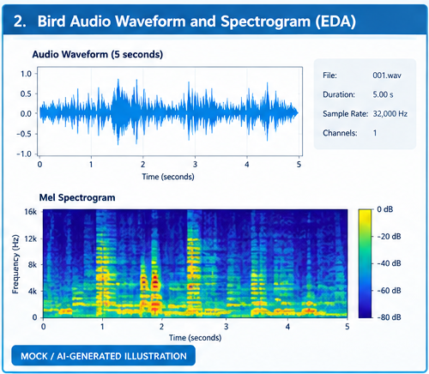
Illustrative project overview.
Muhammad Fayaz
Roll no: 2023_SE_23
Department of Software Engineering
University of Azad Jammu and Kashmir (UoAJK)
Academic Year: 2026

Evidence and Report-Use Note
This report is structured so the supplied images can be inserted directly beside the relevant laboratory steps. The two Kaggle account screenshots are genuine user-provided screenshots. The six progress figures are AI-generated mock illustrations and are clearly labeled as such. Their numerical values are examples for presentation and must not be described as the student's measured results or as official Kaggle leaderboard results.
The official Kaggle competition facts used in this report are based on the BirdCLEF+ 2026 competition page. The competition ran from March 11, 2026 to June 3, 2026, was hosted by Cornell Lab of Ornithology, used five-second prediction windows, and evaluated submissions with a macro-averaged ROC-AUC variant.

Table of Contents
01. 1. Introduction
02. 2. Competition Overview
03. 3. Problem Statement
04. 4. Objectives
05. 5. Dataset and Data Organization
06. 6. Kaggle Notebook Environment
07. 7. Exploratory Data Analysis
08. 8. Audio Preprocessing
09. 9. Proposed Methodology
10. 10. Model Architecture
11. 11. Experimental Setup
12. 12. Evaluation Metric
13. 13. Training Progress
14. 14. Prediction and Inference
15. 15. Error Analysis
16. 16. Discussion
17. 17. Limitations and Future Work
18. 18. Conclusion
19. 19. References
20. Appendix A. Evidence Images

1. Introduction
BirdCLEF+ 2026 is a Kaggle research code competition concerned with automatic acoustic identification of wildlife species in continuous audio from Brazil's Pantanal wetlands. The central idea is to use machine learning to process large amounts of passive acoustic monitoring data that would be difficult to review manually.
The laboratory study presented here follows a complete machine-learning workflow: data understanding, audio exploration, preprocessing, feature extraction, model training, evaluation, and inference. The report is designed as a practical student laboratory document rather than a claim of official competition participation.
2. Competition Overview
The official competition page identifies BirdCLEF+ 2026 as an acoustic species identification task in the Pantanal, South America. It started on March 11, 2026 and closed on June 3, 2026. The host was the Cornell Lab of Ornithology.
The competition requires predictions for five-second audio windows. For each row_id, a probability is produced for each target species. The official evaluation metric is a version of macro-averaged ROC-AUC that skips classes with no true-positive labels. Kaggle also describes it as a code competition in which submissions are made through notebooks.
Verified Competition Information
Item | Information
Competition | BirdCLEF+ 2026
Host | Cornell Lab of Ornithology
Start | March 11, 2026
Close | June 3, 2026
Task | Acoustic species identification / multilabel audio classification
Prediction unit | Five-second audio window
Metric | Macro-averaged ROC-AUC variant
Prize pool | $50,000
Submission | Kaggle Notebook / submission.csv

3. Problem Statement
Passive acoustic monitoring produces continuous recordings containing bird and other wildlife vocalizations, background sounds, and overlapping events. Manual review is expensive and difficult to scale. The problem is to develop a model that estimates which target species are present in each short audio window.
The main technical challenges include class imbalance, noisy field recordings, multiple species occurring at the same time, differences between short training clips and longer soundscapes, and limited labeled soundscape data. A robust system therefore needs both useful acoustic representations and careful validation.

4. Objectives
The objectives of this laboratory are to understand the BirdCLEF+ 2026 task; inspect audio and metadata; visualize waveforms and spectrograms; construct a reproducible five-second preprocessing pipeline; demonstrate a neural audio-classification workflow; understand macro-averaged ROC-AUC; generate a submission-style prediction table; and document the process with visual evidence.

5. Dataset and Data Organization
The competition provides audio and metadata for wildlife identification in the Pantanal. Public Kaggle solution write-ups describe a training set containing 35,549 clips and 234 target species/sonotypes. These figures are cited as competition-level information from public solution documentation, not as counts measured from the student's local files.
Typical analysis begins by inspecting metadata, file paths, labels, durations, and the distinction between focal training audio and longer test soundscapes. Before submitting a final student experiment, exact file counts should be regenerated from the competition input files available to the notebook.

6. Kaggle Notebook Environment
The following screenshots are the student's supplied Kaggle account/workspace evidence. They document the Kaggle environment used while preparing the laboratory work. They should be captioned as user-provided screenshots rather than as official BirdCLEF+ competition results.
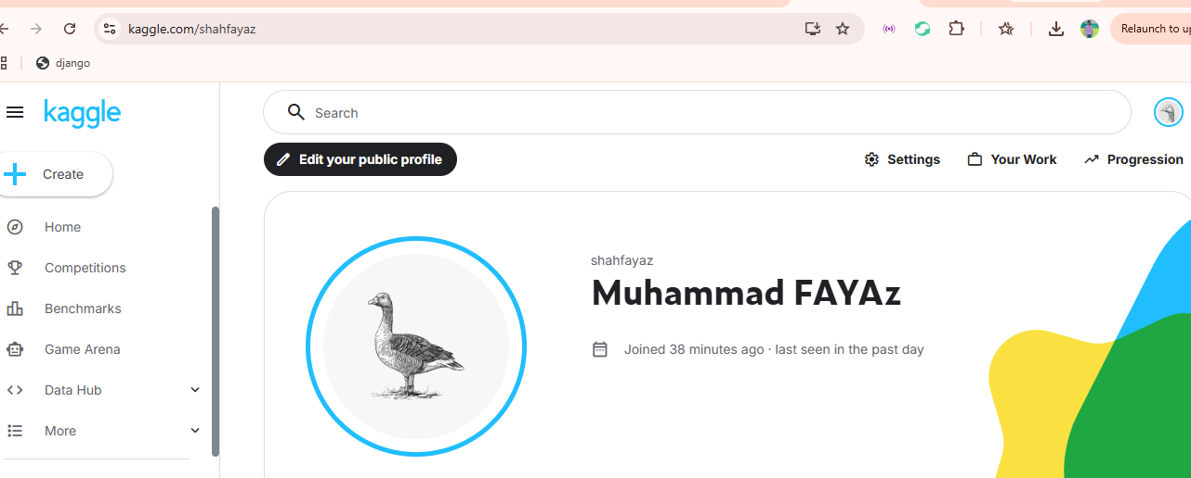
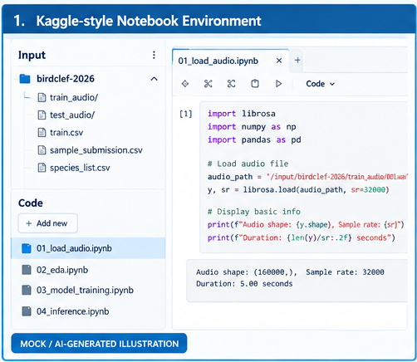
Figure 1. User-provided Kaggle home/workspace screenshot.

7. Exploratory Data Analysis
Exploratory data analysis examines the signal before model training. A waveform displays amplitude against time, while a mel-spectrogram represents energy across frequency bands and time. These representations help identify vocal activity, silence, noise, harmonics, and transient events.
Class-frequency analysis is also important because macro-averaged ROC-AUC gives equal importance to eligible classes. A model that performs well only on frequent species may still have weak performance on rare classes.
Figure 3. waveform and mel-spectrogram EDA.
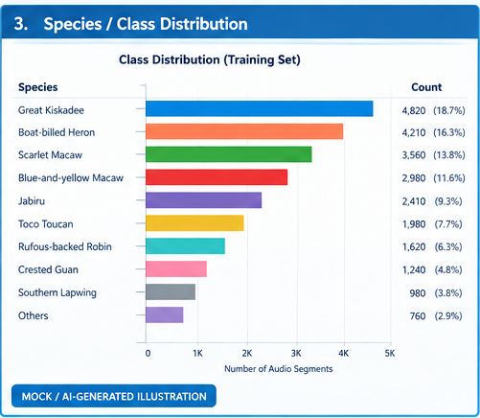
Figure 4 class-distribution illustration. Counts are illustrative.

8. Audio Preprocessing
A reproducible preprocessing pipeline can standardize audio at 32 kHz, convert it to a consistent channel format, normalize the signal, and extract five-second windows. Each window can then be converted into a log-mel spectrogram.
Training-only augmentation may include time shifting, random cropping, background-noise mixing, frequency masking, and time masking. The final report should list the exact parameters actually used by the student's notebook.
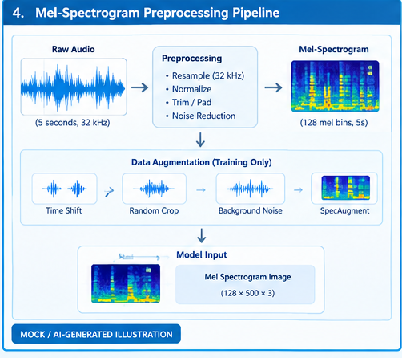
Figure 5. MOCK / AI-GENERATED preprocessing pipeline.
9. Proposed Methodology
The proposed workflow is: obtain the competition data through Kaggle; inspect metadata; prepare grouped training and validation splits; load five-second audio; generate mel-spectrogram features; train a multilabel classifier; evaluate macro ROC-AUC; inspect errors; and generate submission.csv.
A staged workflow is recommended. First validate the complete pipeline on a small subset. Then increase the data size and model complexity only after the preprocessing, training, validation, and inference stages are stable.
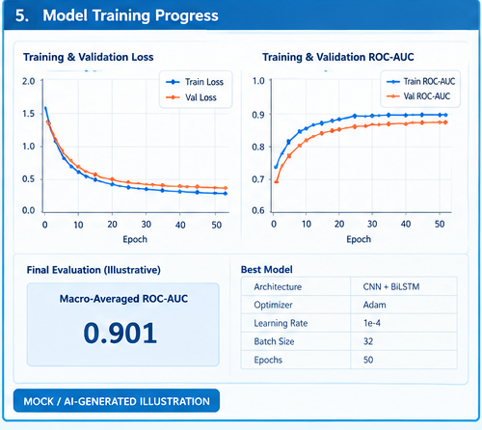

10. Model Architecture
A practical baseline is a convolutional neural network operating on mel-spectrogram images. Convolutional layers learn local time-frequency patterns, while pooling and a multilabel output head produce a probability for each target class.
Public BirdCLEF+ 2026 solution write-ups show more advanced systems using architectures such as EfficientNetV2-based sound-event detection, Perch embeddings, ProtoSSM, ensembles, and pseudo-labeling. These are useful references for future extensions, but a transparent baseline is easier to reproduce in a student laboratory.
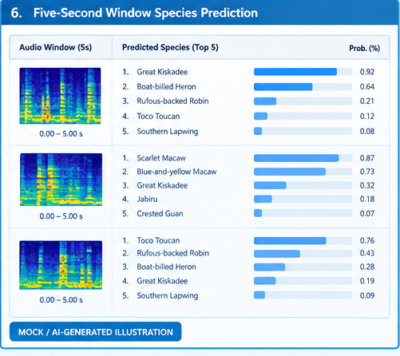

11. Experimental Setup
Every experiment should record the Python environment, package versions, sampling rate, spectrogram parameters, optimizer, learning rate, batch size, number of epochs, augmentation, random seed, and train/validation split.
The official competition code requirements specify notebook-based submission, disabled internet access, and a CPU runtime constraint. The exact runtime rules should be checked on the competition page when reproducing the competition because Kaggle can update competition settings.

12. Evaluation Metric
BirdCLEF+ 2026 uses macro-averaged ROC-AUC with classes that have no true-positive labels skipped. ROC-AUC evaluates ranking quality across thresholds. Macro averaging then gives each eligible class equal weight.
A local validation score and an official Kaggle leaderboard score are different quantities. A local score comes from the student's validation design, while a leaderboard score is calculated by Kaggle using the hidden test data. They should never be presented as interchangeable.

13. Training Progress
The following figure is a visual template showing how training and validation loss and ROC-AUC can be documented. The displayed ROC-AUC and loss values are intentionally illustrative. Replace them with notebook-generated measurements if an actual experiment is performed.
Recommended evidence includes the training log, validation curve, saved model checkpoint, best epoch, optimizer configuration, and the exact validation split.
Figure 6. training progress. Numerical values are illustrative only.
14. Prediction and Inference
During inference, each test soundscape is divided into five-second windows. The model outputs a probability for every target species. These probabilities are placed into a submission table using row_id and the required species columns.
The following figure demonstrates how individual windows can be visualized with their highest-probability species. The names and probabilities in the figure are illustrative and are not official competition predictions.
Figure 7. five-second prediction illustration.

15. Error Analysis
Error analysis should inspect false positives, false negatives, low-confidence windows, rare classes, background noise, overlapping calls, and species with acoustically similar vocalizations.
An effective student experiment can select several validation examples and compare the waveform, spectrogram, true label, predicted probability, and error category. This creates evidence that the model is being evaluated rather than only trained.

16. Discussion
BirdCLEF+ 2026 demonstrates the value of audio representation learning for biodiversity monitoring. Spectrogram-based models can exploit temporal and frequency structure, while pretrained acoustic representations can transfer information from larger collections of recordings.
Public solution write-ups also show that domain shift between focal training clips and field soundscapes is a major issue. This supports the use of grouped validation, soundscape-aware augmentation, and careful error analysis.

17. Limitations and Future Work
The main limitation of this report is that the six progress images are AI-generated mock visuals rather than measured results from the student's own Kaggle run. They are included to demonstrate the correct placement and appearance of laboratory evidence.
Future work should replace every mock metric with actual notebook output, record the exact dataset statistics from the competition input, add real validation examples, and preserve the final notebook version and submission file as reproducibility evidence.

18. Conclusion
BirdCLEF+ 2026 provides a practical case study in acoustic machine learning for biodiversity monitoring. The complete workflow covers audio exploration, preprocessing, spectrogram generation, multilabel classification, validation, and inference.
This report provides a ready-to-edit structure in which each visual is placed near the corresponding laboratory topic. The evidence labels maintain a clear distinction between genuine user screenshots, verified competition information, and AI-generated illustrative figures.

19. References
Stefan Kahl, Tom Denton, Larissa Sugai, Liliana Piatti, Ryan Holbrook, Holger Klinck, and Ashley Oldacre. (2026). BirdCLEF+ 2026. Kaggle.
https://www.kaggle.com/competitions/birdclef-2026
Kaggle. BirdCLEF+ 2026 Code Requirements.
https://www.kaggle.com/competitions/birdclef-2026/overview/code-requirements
Kaggle. BirdCLEF+ 2026 Code / Notebooks.
https://www.kaggle.com/competitions/birdclef-2026/code
Kaggle. BirdCLEF+ 2026 public solution write-ups, consulted for methodology examples and competition-level dataset descriptions.
Appendix A. Image Placement Guide
Figure | Image | Insert after
Figure 1 | Kaggle home screenshot | Section 6 — Kaggle Notebook Environment
Figure 2 | Kaggle profile screenshot | Section 6 — Kaggle Notebook Environment
Figure 3 | Waveform + mel-spectrogram | Section 7 — Exploratory Data Analysis
Figure 4 | Species/class distribution | Section 7 — Exploratory Data Analysis
Figure 5 | Preprocessing pipeline | Section 8 — Audio Preprocessing
Figure 6 | Training curves | Section 13 — Training Progress
Figure 7 | Five-second predictions | Section 14 — Prediction and Inference

